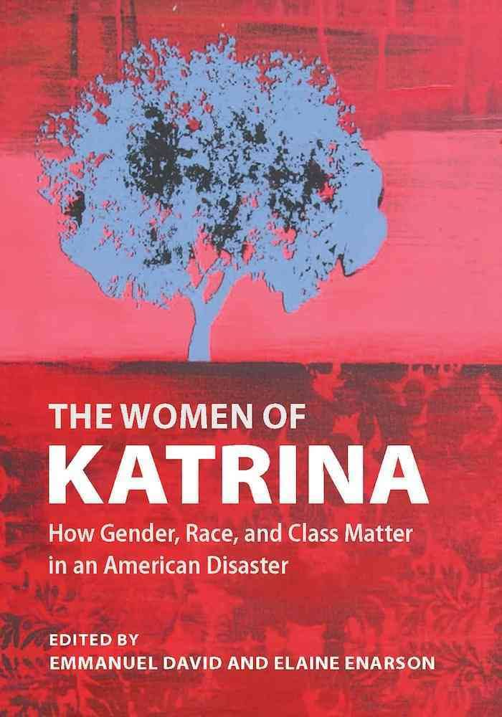

Addressing Social Impacts of Disaster
  - Classroom application
MACEM | MSDE Summer Institute | July 2018

Editorial Reviews
- "The book has the most amazing collection of "eyewitness" accounts. It illustrates a need to understand underlying issues - those that will still be there long after the aid agencies have moved on - and highlights the dangers of making quick-fire assumptions that all too often turn out to be quite wrong. Anyone who thinks they know how to plan for a disaster should read this - at least once a year!" - Association for Human Resources Management in International Organizations
"[A]t the same time David and Enarson urge us to understand women as particularly vulnerable to disaster; they ask us not to see women as in need of protection but as agents whose decisions are enabled and constrained by structural inequalities related to race, class, and gender. And by bringing to light the voices of women [...] we will better understand the complexity and diversity of women's experiences with disaster." - Signs: Journal of Women in Culture and Society

Authors
Elaine Enarson based in Lyons, CO offers distance education courses on gender, social vulnerability, and disaster management. –
Other books: Three study collections on gender and disaster and one on integrating the forest services.
Emmanual David: Villanova University Professor in Sociology/Criminal Justice.
Other Books: Women of the Storm (text)

References
5 pages of research and articles including literature reviews, inquiries on policing and domestic violence and militarism in disaster in New Orleans and elsewhere, other disasters such as a Chicago heat wave, reliable texts; Quarentelli and Drabek, among others.

content
Protest – INCITE! Statement and gender issues.
Testimonials –
Issues – Displacement, parenting, evacuation decisions, poverty.
Community – Culture, gender, faith.
Theory and Practice – Brenda Phillips and Kathleen Tierney

Difficult conversations
- Protecting Students - isn’t possible. Consider in advance what issues you want to address and develop guidance for parking issues for later. Beth Douthert-Cohen will guide us through some of the techniques on Friday.
- Protecting yourself is your priority. There are some issues you can’t tackle in the classroom. Consider having a list of resources for supporting students.
- Protecting the Classroom for learning functionality.

Mission and objectives
- Individual Preparation
- Community Preparation
- Career Training and Education
- Resilience for all

Lesson plans or research assignments .

